Patriot Games 2023 Honoraria Instructions
- Please visit https://fiscal.gmu.edu/purchasing/do-business-with-mason/. Click the hyperlink for the Virginia Substitute W-9, download and fully fill out the form. Then select "Vendor Registration: Submit Completed Substitute COV W-9 or W-8BEN" We cannot take the Substitute W-9 Forms via email or in person anymore. Please do this even if you have submitted a w-9 in the past.
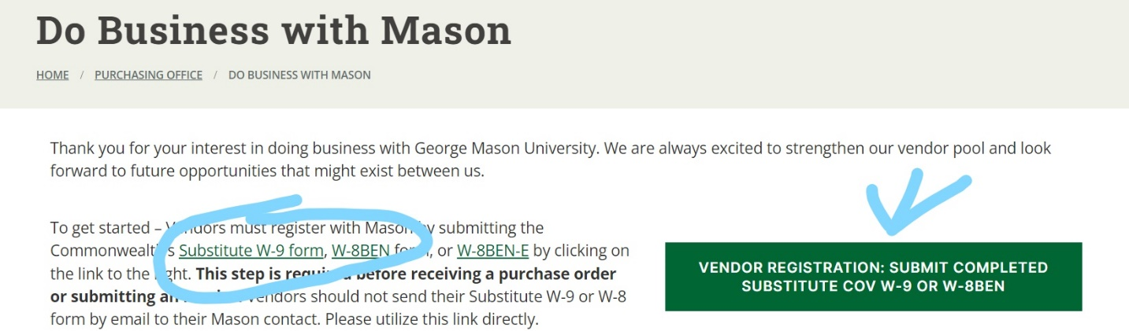

- Fill out the following form:
  - Select the "I am receiving a revenue refund, honorarium, participant support payment, or equivalent" option.
  - Under "George Mason University Contact Information" please put Maria Carabelli, mverdino@gmu.edu.
  - Then you will upload your fully filled out and signed Virginia Substitute W-9. It will need to be printed out, wet signed, and scanned to upload. They will not accept incomplete or incorrectly filled out forms. If you did not download from the previous page, a copy of the W-9’s have been attached. E-SIGNATURES ARE NOT ACCEPTED!!!
