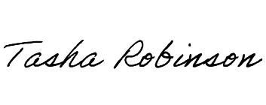
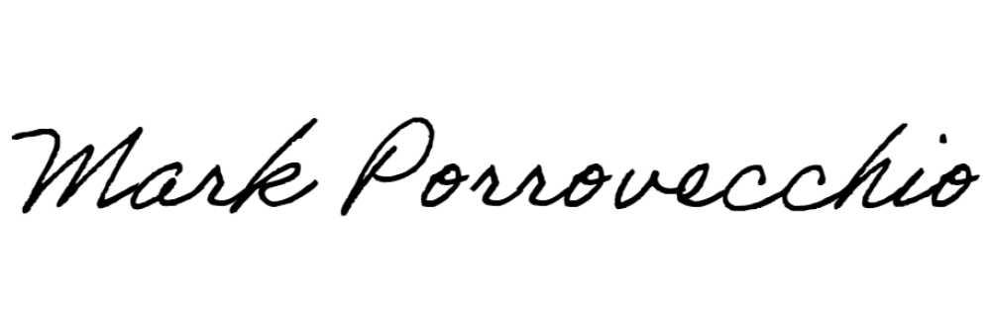
EARL WELLS VIRTUAL SPEAKEASY
OREGON STATE UNIVERSITY
Rachel Woods
Bronze Medal
Open IPDA Debate
December 2-3, 2023
Corvallis, Oregon

Mark Porrovecchio, Director |  | Tasha Robinson, Assistant Dir.

EARL WELLS VIRTUAL SPEAKEASY
OREGON STATE UNIVERSITY
Gwen Skeen
Bronze Medal
Open IPDA Debate
December 2-3, 2023
Corvallis, Oregon

Mark Porrovecchio, Director |  | Tasha Robinson, Assistant Dir.

EARL WELLS VIRTUAL SPEAKEASY
OREGON STATE UNIVERSITY
EMMA MAPLE
Bronze Medal
Open IPDA Debate
December 2-3, 2023
Corvallis, Oregon

Mark Porrovecchio, Director |  | Tasha Robinson, Assistant Dir.

EARL WELLS VIRTUAL SPEAKEASY
OREGON STATE UNIVERSITY
TRICIA CEBOTARI
Bronze Medal
Open IPDA Debate
December 2-3, 2023
Corvallis, Oregon

Mark Porrovecchio, Director |  | Tasha Robinson, Assistant Dir.

EARL WELLS VIRTUAL SPEAKEASY
OREGON STATE UNIVERSITY
SARAH MOTT
Silver Medal
Open IPDA Debate
December 2-3, 2023
Corvallis, Oregon

Mark Porrovecchio, Director |  | Tasha Robinson, Assistant Dir.

EARL WELLS VIRTUAL SPEAKEASY
OREGON STATE UNIVERSITY
ZANE EMERSON
Silver Medal
Open IPDA Debate
December 2-3, 2023
Corvallis, Oregon

Mark Porrovecchio, Director |  | Tasha Robinson, Assistant Dir.

EARL WELLS VIRTUAL SPEAKEASY
OREGON STATE UNIVERSITY
ELLY OSBORNE
Gold Medal
Open IPDA Debate
December 2-3, 2023
Corvallis, Oregon

Mark Porrovecchio, Director |  | Tasha Robinson, Assistant Dir.

EARL WELLS VIRTUAL SPEAKEASY
OREGON STATE UNIVERSITY
NATHAN COOPER
Gold Medal
Open IPDA Debate
December 2-3, 2023
Corvallis, Oregon

Mark Porrovecchio, Director |  | Tasha Robinson, Assistant Dir.

EARL WELLS VIRTUAL SPEAKEASY
OREGON STATE UNIVERSITY
ISSAC TERADA
Bronze Medal
Novice IPDA Debate
December 2-3, 2023
Corvallis, Oregon

Mark Porrovecchio, Director |  | Tasha Robinson, Assistant Dir.

EARL WELLS VIRTUAL SPEAKEASY
OREGON STATE UNIVERSITY
MINASE LEGESSE
Bronze Medal
Novice IPDA Debate
December 2-3, 2023
Corvallis, Oregon

Mark Porrovecchio, Director |  | Tasha Robinson, Assistant Dir.

EARL WELLS VIRTUAL SPEAKEASY
OREGON STATE UNIVERSITY
TIMOTHY LAMBERT
Bronze Medal
Novice IPDA Debate
December 2-3, 2023
Corvallis, Oregon

Mark Porrovecchio, Director |  | Tasha Robinson, Assistant Dir.

EARL WELLS VIRTUAL SPEAKEASY
OREGON STATE UNIVERSITY
ATILLA ELIK
Bronze Medal
Novice IPDA Debate
December 2-3, 2023
Corvallis, Oregon

Mark Porrovecchio, Director |  | Tasha Robinson, Assistant Dir.

EARL WELLS VIRTUAL SPEAKEASY
OREGON STATE UNIVERSITY
KEIDA PATTERSON
Silver Medal
Novice IPDA Debate
December 2-3, 2023
Corvallis, Oregon

Mark Porrovecchio, Director |  | Tasha Robinson, Assistant Dir.

EARL WELLS VIRTUAL SPEAKEASY
OREGON STATE UNIVERSITY
SEAMUS MAHONEY
Silver Medal
Novice IPDA Debate
December 2-3, 2023
Corvallis, Oregon

Mark Porrovecchio, Director |  | Tasha Robinson, Assistant Dir.

EARL WELLS VIRTUAL SPEAKEASY
OREGON STATE UNIVERSITY
EMERSON PEARSON
Gold Medal
Novice IPDA Debate
December 2-3, 2023
Corvallis, Oregon

Mark Porrovecchio, Director |  | Tasha Robinson, Assistant Dir.

EARL WELLS VIRTUAL SPEAKEASY
OREGON STATE UNIVERSITY
IZE UPHAM
Gold Medal
Novice IPDA Debate
December 2-3, 2023
Corvallis, Oregon

Mark Porrovecchio, Director |  | Tasha Robinson, Assistant Dir.

