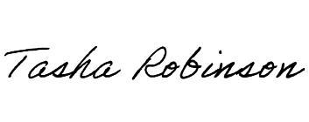
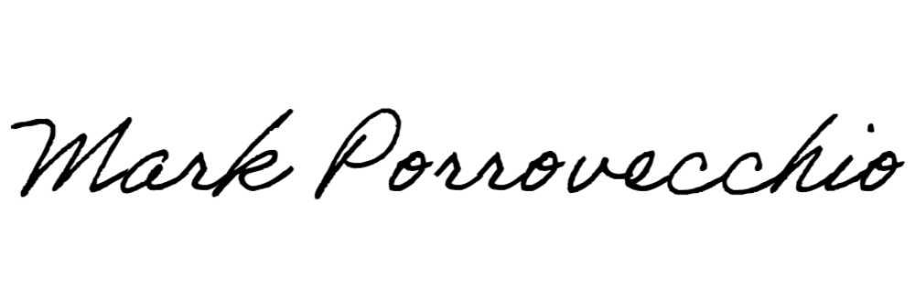
EARL WELLS VIRTUAL SPEAKEASY
OREGON STATE UNIVERSITY
SARAH MOTT
Best Speaker
Open IPDA Debate
December 2-3, 2023
Corvallis, Oregon

Mark Porrovecchio, Director |  | Tasha Robinson, Assistant Dir.

EARL WELLS VIRTUAL SPEAKEASY
OREGON STATE UNIVERSITY
RYDER EVANS
Second Best Speaker
Open IPDA Debate
December 2-3, 2023
Corvallis, Oregon

Mark Porrovecchio, Director |  | Tasha Robinson, Assistant Dir.

EARL WELLS VIRTUAL SPEAKEASY
OREGON STATE UNIVERSITY
ELLY OSBORNE
Third Best Speaker
Open IPDA Debate
December 2-3, 2023
Corvallis, Oregon

Mark Porrovecchio, Director |  | Tasha Robinson, Assistant Dir.

EARL WELLS VIRTUAL SPEAKEASY
OREGON STATE UNIVERSITY
Tricia Cebotari
Fourth Best Speaker
Open IPDA Debate
December 2-3, 2023
Corvallis, Oregon

Mark Porrovecchio, Director |  | Tasha Robinson, Assistant Dir.

EARL WELLS VIRTUAL SPEAKEASY
OREGON STATE UNIVERSITY
RACHEL WOODS
Fifth Best Speaker
Open IPDA Debate
December 2-3, 2023
Corvallis, Oregon

Mark Porrovecchio, Director |  | Tasha Robinson, Assistant Dir.

EARL WELLS VIRTUAL SPEAKEASY
OREGON STATE UNIVERSITY
EMERSON PEARSON
Best Speaker
Novice IPDA Debate
December 2-3, 2023
Corvallis, Oregon

Mark Porrovecchio, Director |  | Tasha Robinson, Assistant Dir.

EARL WELLS VIRTUAL SPEAKEASY
OREGON STATE UNIVERSITY
IZE UPHAM
Second Best Speaker
Novice IPDA Debate
December 2-3, 2023
Corvallis, Oregon

Mark Porrovecchio, Director |  | Tasha Robinson, Assistant Dir.

EARL WELLS VIRTUAL SPEAKEASY
OREGON STATE UNIVERSITY
KEIDA PATTERSON
Third Best Speaker
Novice IPDA Debate
December 2-3, 2023
Corvallis, Oregon

Mark Porrovecchio, Director |  | Tasha Robinson, Assistant Dir.

EARL WELLS VIRTUAL SPEAKEASY
OREGON STATE UNIVERSITY
OWEN RONNINGEN
Fourth Best Speaker
Novice IPDA Debate
December 2-3, 2023
Corvallis, Oregon

Mark Porrovecchio, Director |  | Tasha Robinson, Assistant Dir.

EARL WELLS VIRTUAL SPEAKEASY
OREGON STATE UNIVERSITY
MINASE LEGESSE
Fifth Best Speaker
Novice IPDA Debate
December 2-3, 2023
Corvallis, Oregon

Mark Porrovecchio, Director |  | Tasha Robinson, Assistant Dir.

