2024 Showdown In Joe Town OPEN

Dear Speech and Debate Coaches and Teams:

The Benton, Central, and Lafayette High Schools Chapters of the National Speech and Debate Association cordially invites you to our first annual Showdown in Joe Town Open to be held on January 19th and 20th. This year, the Showdown in Joe Town will be held at Lafayette High School (this will be a rotating tournament each year, hosted by BHS, CHS, and LHS).

Events at the Varsity tournament will include:
Lincoln-Douglas Debate Public Forum Debate Policy Debate
Student Congress US Extemporaneous Speaking International Extemporaneous Speaking Humorous Interpretation Dramatic Interpretation Duo Interpretation
Original Oratory Program Oral Interpretation Informative Speaking
LIVE RADIO SPEAKING Poetry/Prose Storytelling

Policy Debate: Resolved: The United States federal government should substantially increase
fiscal redistribution in the United States by adopting a federal jobs guarantee, expanding Social Security, and/or providing a basic income.
Lincoln-Douglas: Resolved: The United States ought to substantially reduce its military presence
in the West Asia-North Africa region.

Public Forum: Resolved: The United States federal government should repeal Section 230 of the
Communications Decency Act.

Student Congress: December 2022 NSDA legislation

We will guarantee 2 entries in each event and then all other entries will be waitlisted upon entry. Extra entries will be awarded as available and at the discretion of the host school. Entry fees will be 8.00/entry.

Submit entries on SpeechWire:
Showdown in Joe Town
The deadline for entries is Wednesday, January 10th, 3 pm.

Please note: Though LHS is not completely inaccessible, it is not particularly wheelchair-friendly. If you have a student(s) who is wheelchair-bound and/or struggles with stairs, please let me know who and in what event(s) he/she will compete in, so that I may reassign rooms to better accommodate him/her.

Sincerely,

Dr. Shane Heard BHS S/D Coach shaneheard@sjsd.k12.mo.us 816.261.3358
Chris Thomas BHS S/D Coach christhomas@sjsd.k12.mo.us 816.279.1136
Joseph Barbosa CHS S/D Coach josephbarbosa@sjsd.k12.mo.us 816.262.4693
Carter Clark LHS Coach carterclark@sjsd.k12.mo.us 816.383.2095

TOURNAMENT SCHEDULE

Friday, January 20th

2:30-3: Registration
3:00: Round 1 Extemp Draw
3:30: Round 1 Individual Events
4:30: Round 2 Extemp Draw
5:00: Round 2 Individual Events
(Hidden Final During Round 3 with Paneled Judges)
6:30: Round 3 Extemp Draw
7:00: Round 3 Individual Events
ASAP Awards: IE Awards, Overall Speech Sweeps Award

Saturday, January 21st

8:00: Round 1 Debate
9:45: Round 2 Debate
11:15: Round 3 Debate
12:45: Round 4 Debate
2:15: Round 5 Debate
ASAP Awards: Debate Awards, Overall Debate and Team Sweeps Award

General Information and Rules

- NOTE: Novice BHS, CHS, and LHS students will be allowed to compete in the tournament. Due to the fact that BHS, CHS, and LHS will have students participating in this tournament, a grievance committee has been established in case there is an issue with judging (though, of course, all judges will be screened and conflicts will be removed).
- School will be released at 1:35 (an hour early!). Please arrive after 2pm. Drop off in front of the school (see map). Busses park in the Football Parking Lot, north of the school (see map).
- Registration will be in front of the auditorium, top main stairs.
- Tabulation Room: Tab will be open throughout the tournament in the Library Media Center.
- Facilities and Concessions:
  - Students should remain in the common area (Cafeteria) between rounds.
  - All postings will be made public in the hallway outside of the Cafeteria.
  - A concession stand will be available.
  - Lafayette High School is a non-smoking campus.

- Coaches, Judges, and Bus Drivers:
  - A hospitality room will be provided for judges, bus drivers, and coaches in Room 11.
  - Busses need to park in the Football Parking Lot, north of the school. (See Map Below).

Competition Information and Rules

- Speech and Congress Events will be held on Friday ONLY. IEs will have three rounds with a hidden final held and with paneled judges in the 3rd round. Congress will have two rounds and then a Super Session Final.
- Debate will be held on Saturday ONLY. Debate will have 5 rounds (4 Rounds of CX). Places will be determined out of those 5 round of scores.
- Each school shall be guaranteed up to two entries in each competitive event offered. Extra entries will be granted on a basis of space availability and order of submitted entries.
- A student may not enter both divisions of Extemp speaking, nor enter more than one division of debate.
- Students may not do Congress and another Individual Event.
- No Maverick teams will be allowed in any division of debate.
- MSHSAA rules of conduct will be enforced.
- WIFI will be made available to all competitors in debate and extempers.
- Tab will be open for view throughout the tourney. Results will become permanent 10 min. after final tab.
- A student may not use the same selection for more than one event.
- Each school must have an adult sponsor, able to judge at all times.
- Trophies: Trophies will be given to the top six entries in individual events and the top eight in debate.
- Hillyard, Inc. (Overall) Sweepstakes:We will be offering:
      - Overall Speech Sweeps Trophy (presented at Friday Awards)
      - Overall Debate Sweeps Trophy (presented on Saturday Awards)
      - Overall 1st, 2nd, and 3rd Place Sweeps Trophy (presented on Saturday Awards)
IE Sweeps will be awarded in the following: For the top 6 in the finals room: 1st: 30pts, 2nd: 25pts, 3rd: 20pts, 4th: 15pts, 5th: 10pts, 6th: 5pts

Debate Sweeps will be awarded in the following: 5 Pts for a Loss. 10pts for a win. Finals (Including Congress): 1st: 30pts, 2nd: 25pts, 3rd: 20pts, 4th: 15pts, 5th-8th:10pts

Overall Sweeps (1st, 2nd, and 3rd) will be awarded from a combination of both IE and Debate Sweeps.
Debate Events

LINCOLN DOUGLAS DEBATE:
- Our tournament will use the NSDA 2023 January/February Lincoln-Douglas topic.
- Time limits for Lincoln Douglas debate will be: 6-3-7-3-4-6-3.
- Each debater will be allowed a total of 4 minutes of prep time
- Tie-breakers: Ballots won, Opp wins, Total pts, Opp ranks, Opp-opp wins
- A debater more than ten minutes late to a round will forfeit unless it is the fault of the tournament.
- Debaters are allowed to use laptops in rounds but must follow MSHSAA guidelines.

PUBLIC FORUM DEBATE:
- Our tournament will use the NSDA 2023 January Public Forum topic.
- PF debate will be: 4-4-3-4-4-3-3-3-3-2-2. Each team will be allowed a total of 4 minutes of prep time.
- Sides will be determined by a coin flip at the start of each round.
- Tie-breakers: Ballots won, Opp wins, Total pts, Opp ranks, Opp-opp wins
- No maverick teams will be allowed to debate.
- A team more than ten minutes late to a round will forfeit unless it is the fault of the tournament.

POLICY DEBATE:
The resolution will be the NSDA/MSHSAA approved topic.
- Time limits will be 8-3-5. Each team will be allowed a total of 8 minutes of prep time.
- Tie-breakers: Ballots won, Opp wins, Total pts, Opp ranks, Opp-opp wins
- No one-person teams will be allowed to debate.
- A team more than ten minutes late to a round will forfeit unless it is the fault of the tournament.
- Debaters are allowed to use laptops in rounds and must follow MSHSAA rules.
- No one-person teams will be allowed to debate. Team personnel must remain constant throughout the tournament.

STUDENT CONGRESS- December 2023 NSDA legislation packet. The judges and parliamentarian will rank the students at the end of each session which determines who advances to Super Session.
Criteria for advancing and placing in Student Congress will be as follows:
Advancing to Super Session:
1. Cume of judge in sessions one and two
2. Recips for ranks of judge and parliamentarian in session one and two
Placing in Super Session:
1. Cume of Super Session judges
2. Recips for Super Session ranks of judges and parliamentarian
Congress legislation will be included in the invite. We are using the December 2023 Congress Legislation Packet. As a coach, we are requesting that you assign students one piece of the legislation and side per round according to the following constraints:
- Session 1, 3, 8, 9
- Session 2: 4, 1, 6
- Super Session: 5, 10, 7

Individual Events

HUMOROUS OR DRAMATIC INTERPRETATION:
Selections must be taken from published literature (play, novel, short story). NSDA guidelines will apply. Selections should possess literary merit and be appropriate for a high school performance. The performance, including the introduction, must be memorized.
MSHSA RULES WILL BE FOLLOWED: Time: 10 min. time limit. No Grace Period

DUO INTERPRETATION:
Selections must be taken from published works including novels, short stories, plays, or poetry. NSDA guidelines will apply. The performance, including the introduction, must be memorized.
MSHSA RULES WILL BE FOLLOWED: Time: 10 min. time limit. No Grace Period

PROGRAM ORAL INTERPRETATION:
Sections must be taken from 2-3 genres and from published literature (i.e., prose, poetry, drama, plays, novels, short stories, etc.). NSDA guidelines apply. Selections should possess literary merit and must be appropriate for a high school performance. The performances should include an introduction and must be memorized. All components must be verbally identified by title and author. Binders or folders must be used.
NSDA RULES WILL BE FOLLOWED: Time: 10 min. time limit. 30 Second Grace Period

INTERNATIONAL AND U.S. EXTEMPORANEOUS SPEAKING:
Drawing of current event topics will be conducted at five-minute intervals. A total of 30 minutes prep time will be allowed. No consultation with others is allowed during prep time. Not allowed to enter both exempts.
MSHSA RULES WILL BE FOLLOWED: Time: 7 min. time limit. No Grace Period

INFORMATIVE SPEAKING:
Students deliver a self-written, ten-minute speech on a topic of their choosing. Not more than 150 words may be in the form of a direct quotation. Informative speakers may use visual aids that comply with the NSDA informative speaking rules. All topics must be informative in nature; the goal is to educate, not to advocate. The speech should be memorized.
MSHSA RULES WILL BE FOLLOWED: Time: 10 min. time limit. No Grace Period

ORIGINAL ORATORY:
This persuasive speech must be the original work of the contestant. Not more than 150 words may be in the form of a direct quotation. The speech must be memorized. A student may not repeat an oratory he/she used in any previous year of competition.
MSHSA RULES WILL BE FOLLOWED: Time: 10 min. time limit. No Grace Period

RADIO SPEAKING:
The student entering radio speaking shall prepare and present a script which contains news, weather, and sports, use copy no more than 24 hours old - as of the Tournament's first round - to prepare the script, use no commercials, and not portray multiple characters. Each presentation shall be read without the use of a microphone. The speaker shall turn his or her back to the judge while giving the presentation.
MSHSA RULES WILL BE FOLLOWED: Time: 5 min. time limit. No Grace Period

STORYTELLING – Selections must come from published material. The memorized introduction may be given in a standing or seated position. The contestant shall narrate the story in a combination of his/her own words and original essential phrases, and from a seated position on a chair or stool.
MSHSA RULES WILL BE FOLLOWED: Time: 8 min. time limit. No Grace Period

PROSE/POETRY INTERPRETATION: Scripts must be used (READ FROM) and taken from a published source of quality literature. Prose selections are not to be more than 50% dialogue. Binders or folders must be used. NOTE: The student can have poetry AND/OR prose selections to perform.
MSHSA RULES WILL BE FOLLOWED: Time: 8 min. time limit. No Grace Period

Directions for Drop-off and Parking

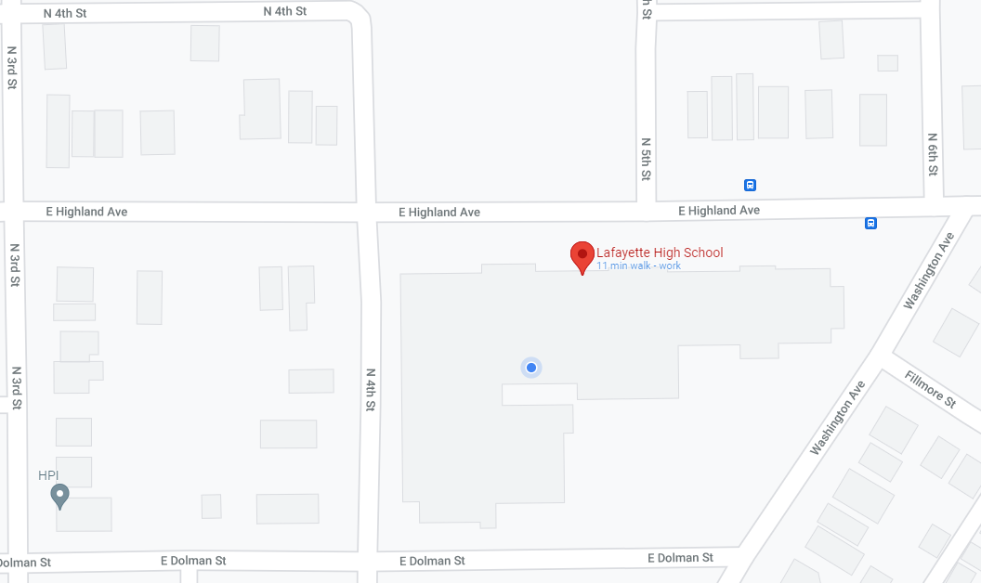
DROP OFF
1. From I-229
Ext 7
Football Parking Lot

BUS PARKING
6a. Prior to 2:30: Turn Left on E. Highland travel under I 229 to Remington Nature Center.

6b. After 2:45: Turn Right and go to Football Parking Lot
3. Turn Right on Dolman
5. Turn Right on N. 3rd St
LHS

